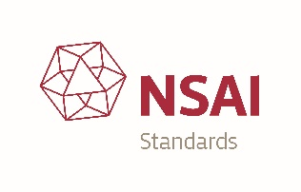

Latest news from ISO TC 276 and NSAI TC 62

The National Standards Authority of Ireland, NSAI is a member body of ISO. Through this membership, national stakeholders can access information and draft developing standards. NSAI TC 62 – NSAI Biotechnology Standards Consultative Committee, chaired by Dr Suzanne bracken of HRB-CRCI (Clinical Research Coordination Ireland), is the national forum for contribution to
ISO TC 276 (Biotechnology).

This is facilitated by:
- Ensuring national experts can access international working groups and working documents
- Nominating national experts to get involved in relevant international working groups and attend international meetings
- Monitoring output of ISO TC 276 to ensure national interests are addressed
- Providing comment and national input on the development of international standards to ensure national stakeholders are not disadvantaged
- Keeping national stakeholder informed of relevant international biotechnology standards information in the field

One of the outputs of ISO TC 276 includes ISO 20387 – Biotechnology - Biobanking – General requirements for biobanking which was published in 2018. An implementation guide to this standard is also being developed ISO TR 22758 – Biotechnology – biobanking – implementation guide for ISO 20387 and is due for publication in 2020.

An update of current developments under each WG under ISO TC 276 is outlined below.

WG1: Terminology - is working on terminology co-ordination to ensure clear understanding and use of terms among ISO TC 276 Working Groups. The proposed TR of terms is to be used as in internal TC document and is to be maintained as an "inventory" of terms.

WG2: Biobanks and bioresources - has developed ISO 20387, the main biobanking standard, which is now published. This is viewed as the "umbrella" standard for this group – see Figure 1.

WG2 is also looking at several specific areas for standard development relating to biobanking. Cell culture, mesenchymal cells, animal genetic resources and plant genetic resources are topics that are being considered for standard development.
They are also developing a standard on validation and verification methods.

See Appendix 1 for more details of WG2 current work programme.

Figure 1 Overview of ISO TC 276 WG2 Work Programme

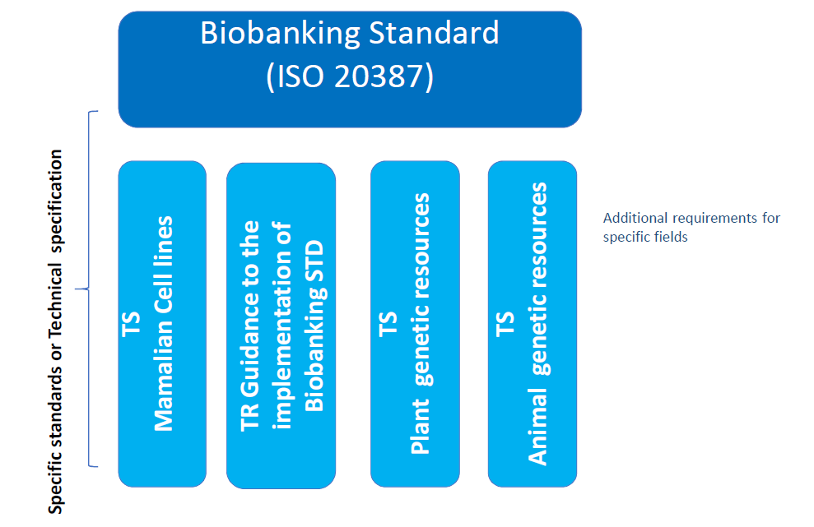

WG3: Analytical methods - is developing a suite of analytical methods for biotechnology. The approach taken is to develop "umbrella standards" and "vertical standards". Umbrella standards will deal with topics such as proteins, products containing human cells for therapeutic use, oligonucleotides, genomes and delivery systems/vectors. Vertical standards will address attributes, techniques and materials. For example, attribute standards being developed include cell counting, cell line authentication, viability. For more information see Figure 2.

Figure 2 – ISO TC 276 WG3 Programme: suite of analytical methods for biotechnology
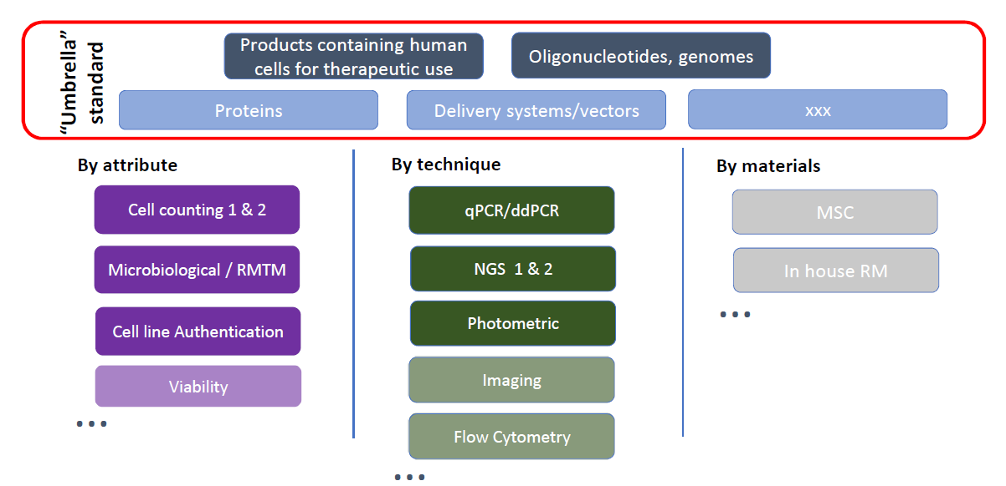

WG4: Bioprocessing - plans to develop standards to ensure consistent, controlled and tracked processes to give confidence to suppliers and users of products. The group is working on four major technology spaces:
- Component material control
- Upstream processes (e.g. cell cultivation, fermentation and bioconversion)
- Downstream processes (e.g. collection separation, purification and formulation)
- Handling, transportation and storage.

The following standards are now published by ISO:
- ISO/TS 20399-1:2018 - Biotechnology -- Ancillary materials present during the production of cellular therapeutic products -- Part 1: General requirements.
- ISO/TS 20399-2:2018 - Biotechnology -- Ancillary materials present during the production of cellular therapeutic products -- Part 2: Best practice guidance for ancillary material suppliers.
- ISO/TS 20399-3 - - Biotechnology -- Ancillary materials present during the production of cellular therapeutic products – Best practice guidance for ancillary material users.

The plan is to combine the above TS's documents into one standard in the near future.

See appendix 1 for more information of the WG4 work programme.

WG5: Data processing and integration - is working on standards for data processing and integration in the context of biobanking, see Table 3 for the list of current projects under WG5.

Table 3 - Approved projects under WG5 work programme.

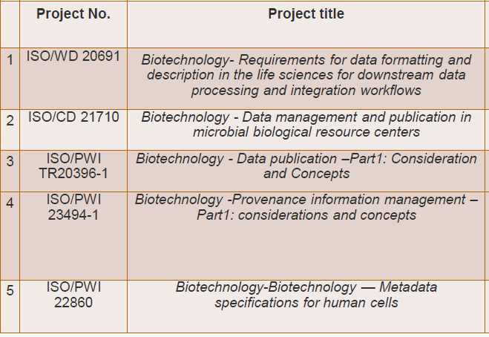
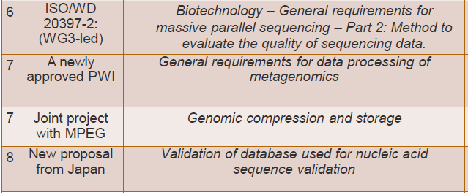

New areas being investigated for standardization include:
- Proposed Technical Report - Biotechnology – data publication – considerations and concepts.
- ISO/PWI – General requirements for data processing of metagenomics.

See the link below for the current ISO TC 276 work programme:
www.iso.org/committee/4514241/x/catalogue/p/1/u/1/w/0/d/0

For more information on how to participate in this and other standard development, please contact:
- Linda Hendy, NSAI (Secretary) linda.hendy@nsai.ie
- Dr Suzanne Bracken, CRDI (Chair) suzanne.bracken@crdi.ie

Appendix 1 – Details of Work Items (WI) being developed by ISO TC 276 Working Groups (WG)

WG2 – Biobanks and bioresources
Current work items under development

- ISO WD 21709 - Biotechnology — Biobanking — Process and quality requirements for establishment, maintenance and characterization of mammalian cell lines
- ISO DIS 21899 - Biotechnology — Biobanking — General requirements for the validation and verification of processing methods in biobanks
- ISO WD TS 20388 - Biotechnology — Biobanking — Collection, processing, storage and transportation criteria for animal biological material
- ISO WD TS 23105 - Biotechnology — Biobanking — Collection, processing, storage and transportation criteria for plant biological material
- ISO WD TS 22859-1 – General guidelines for biobanking human mesenchymal stem and stroma cells derived from the umbilical cord.
- ISO PWI 22859-2 – Biotechnology – biobanking – general guidelines for biobanking human mesenchymal stromal cells derived from bone marrow
- ISO PWI 24088 – Biotechnology – biobanking – collection processing, storage and transportation requirements for prokaryotic resources
- Biotechnology – biobanking – the establishment, maintenance, characterization and distribution requirements for pluripotent stems cells

WG3 – Analytical methods
Current work items under development

- ISO PWI 24421 - Biotechnology - Minimum requirements to assure optical signal quality of photometric methods for biological measurements
- ISO/CD 23033 Biotechnology – Cell Characterization – General guide for characterization of human cells for therapeutic applications.
- ISO/CD 23033 Biotechnology – Analytical methods - General guide for the characterization and testing of cellular therapeutic products.
- ISO/CD 23033 Biotechnology – Cell Characterization – General guide for characterization of human cells for therapeutic applications.
- ISO/CD 20397-2 Biotechnology - General requirements for massive parallel sequencing – Part 2: Methods to evaluate the quality of sequencing data.
- ISO/CD 20397-2 Biotechnology - General requirements for massive parallel sequencing - Part 2: Methods to evaluate the quality of sequencing data.
- ISO/DIS 20688-1 Biotechnology – Nucleic acid synthesis – Part 1: General definitions and requirements for the production and quality control of synthesized oligonucleotides.
- ISO/PWI 20688-2 Biotechnology – Nucleic acid synthesis – Part 2. General definitions and requirements for the production and quality control of synthesized gene fragments, genes, and genomes.
- ISO/PWI 20688-2 Biotechnology – Nucleic acid synthesis – Part 2. Requirements for the production and quality control of synthesized gene fragments, genes, and genomes.

WG4 – Bioprocessing
Current work items under development

- ISO/CD 21973 – Biotechnology – General requirements for transportation of cells for therapeutic use.
- ISO AWI TS 23565 – Biotechnology – bioprocessing – General requirements and considerations for equipment systems used in manufacturing of cellular therapeutic products.

Topics being discussed and investigated for possible standard development include cell manufacturing or "cell manufacturability" and requirements for package of cells for therapeutic use.

