Welcome to the Webinar - Information Session on the Standard on “Universal Design Dwellings”

17th April 2023

Webinar – Housekeeping
The Webinar will be recorded
- ISL and captioning are provided
- There will be a 10 minute comfort break during the webinar
- Time has been allocated for Q & A session during the Webinar
- The Webinar recording will be available after the event

Webinar – Housekeeping Cont

- NSAI will be monitoring the Q & A function
- If you have any questions please use this function during the Webinar
- There will be a Q & A session at the end of the webinar
- Chat function – is not being monitored

Standard on Universal Design (UD) Dwellings

Webinar – Information Session, 17th April 2023 10am to noon

Welcome

Elizabeth O Ferrall

Project manager at NSAI & NSAI/TC23 Universal Design Standards Consultative Committee (UDSCC)

NSAI – Role in standardisation
- NSAI is the National Standards Authority of Ireland
- Established under the NSAI Act of 1996
- (http://www.irishstatutebook.ie/eli/1996/act/28/schedule/1/enacted/en/ht ml )
- Facilitates stakeholders to participate in the development of standards at National, European (regional) and International level
- Governed by Regulation(EU) No 1025/2012 on standardisation (https://eur- lex.europa.eu/LexUriServ/LexUriServ.do?uri=OJ:L:2012:316:0012:0033:EN:PDF )

Agenda
- Welcome and Introductions, Elizabeth O’Ferrall
- Overview of Universal Design and Standards, Gerald Craddock
- Background: Key existing Built Environment Standards, Tom Grey
- Why develop a standard for Universal Design Dwellings? Ruth O’Reilly
- 10 minute comfort break
- Standard development process and timelines, Tom Grey
- Q & A
- Wrap Up and close, Ruth O’Reilly

Welcome from the Chairs of the NSAI National Committee – NSAI/TC23

Gerald Craddock, Chair NSAI/TC23 Universal Design Standards Consultative Committee
Tom Grey, Chair NSAI/TC23/SC1 Accessibility of the built environment
Ruth O’Reilly, Chair NSAI/TC23/SC1/WG6 UD Dwellings

Overview, Ger Craddock

Centre for Excellence in Universal Design (CEUD)

The Centre for Excellence in Universal Design is the only statutory centre for Universal Design in the World

Physical and digital environments, services and systems

Universal Design

Universal Design is the design and composition of an environment so that it can be accessed, understood and used to the greatest extent possible by all people, regardless of their age, size, ability or disability.

Universal Design Systems Hierarchy
Macro:
Policy
Legislation
Standards
Meso:
Monitoring/Certification
Codes of Practice
Micro:
Resources/Toolkits
Training & Support
Adopted from NewSouth Wales Government Australia (with permission)

NSAI/TC23 Universal Design Standards Consultative Committee (UDSCC)

NSAI/TC023
Chair of the NSAI/TC23/ is Dr Gerald Craddock (CEUD)
Sub Committee 1 – Built Environment
Sub Committee 2 – ICT
Sub Committee 3 – Products/Services
Sub Committee 4 – Assistive Technology
Sub Committee 5 – Products and services – range of users
Sub Committee 6 – Ageing societies
Universal

NSAI/TC023/ Sub Committee1

Accessibility of the Built Environment

Structure of the NSAI / TC023/ SC1 Accessibility of the Built Environment

Chair of NSAI / TC023/ Sub Committee 1 is Tom Grey, TrinityHaus, TCD

Sub Committee (SC)1 is composed of a number of working groups (WG).
Working Group 2 Mapped to CEN.CLC.JTC11
Working Group 3 Mapped to ISO/TC59/SC16
Working Group 4 Mapped to CEN/TC10 (Lifts)
Working Group 5 Mapped to ISO/TC314/Working group 7
Working Group 6 (UD Dwellings) was established to facilitate the development of the standard on “Universal Design (UD) Dwellings”. The Chair is Ruth O’Reilly, NDA

Standards
National:
National Standards Authority Ireland (NSAI) - Universal Design Standards
Consultative Committee (UDSCC) – chair and co-ordinate 5 sub committees (SC’S) anda number of working groups (WG’s) in partnership with NSAI,
Develop and comment on standards
European:
CEN, CENELEC and ETSI – representing Ireland at chair and participant level in a number of standards committees
International:
International Standards Organisation (ISO) - Representing Ireland at chair and participant level in a number of standards committees.
ITU – International Telecommunications Union – participant in working groups re ICT and accessibility

Background:

Key existing built environment standards, Tom Grey

I.S EN 17210:2021

I.S. EN 17210:2021 and the two supporting documents are the adopted Irish versions of the 2021 European standards covering Accessibility and usability of the built environment

Accessibility and usability of the built environment – Functional requirements

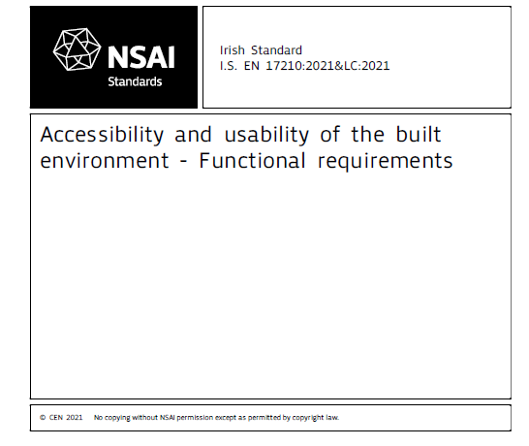
Common minimum functional
requirements & recommendations
to achieve an accessible and usable built environment underpinned by Design for All/Universal Design

Accessibility and usability of the built environment – Technical performance criteria and specification
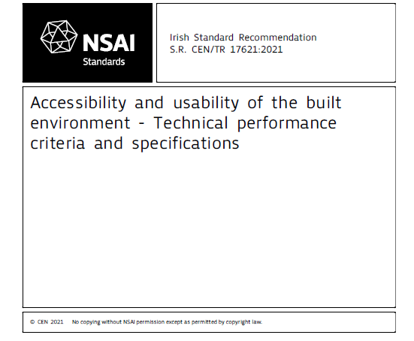
Technical performance criteria and specifications to fulfil the functional requirements & recommendations of I.S. EN 17210

Accessibility and usability of the built environment – Conformity assessment
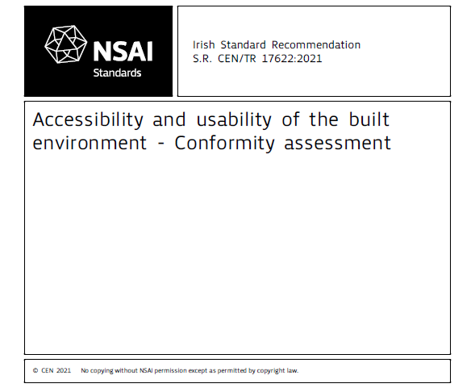
Criteria to assess conformity of the built environment with the functional requirements & recommendations in I.S. EN 17210

Public and Private Procurement
Support Of European Accessibility Requirements for Public and Private Procurement In the Built Environment
Why procurement is important: Public procurement as an example -
Every year, over 250 000 public authorities in the EU spend around 14% of GDP (around €2 trillion per year) on the purchase of services, works and supplies
In many sectors such as energy, transport, waste management, social protection and the provision of health or education services, public authorities are the principal buyers.
The public sector can use procurement to boost jobs, growth and
investment, and to create an economy that is more innovative, resource and energy efficient, and socially-inclusive.
https://ec.europa.eu/growth/single-market/public-procurement_en

I.S. EN 17210: 2021 - 1 Scope

This document describes basic, minimum functional requirements and recommendations for an accessible and usable built environment, following "Design for All"/"Universal Design" principles which will facilitate equitable and safe use for a wide range of users, including persons with disabilities. The requirements and recommendations given in this document are applicable across the full spectrum of the built environment.
These functional accessibility and usability requirements and recommendations are relevant to the design, construction, refurbishment or adaptation, and maintenance of built environments including outdoor pedestrian and urban areas.

Accessibility and usability of the built environment – Functional requirements

Main Document Contents

Introduction
- Scope
- Normative references
- Terms and definitions
- Legal and policy
- Diversity of users and design considerations
- Wayfinding
- Access in the outdoor environment
- Arrival and departure areas – Parking areas
- Horizontal circulation in buildings
- Vertical circulation in buildings and outdoors

- Specific indoor and outdoor areas, equipment and provisions
- Sanitary accommodation
- User interface, controls and switches
- Fire safety for all -
Evacuation and emergency exits
- Environmental conditions in buildings
- Accommodation
- Cultural, leisure and sport buildings
- Administrative, service and employment buildings
- Outdoor and urban areas
- Transport facilities

Accessibility and usability of the built environment – Functional requirements - Cont

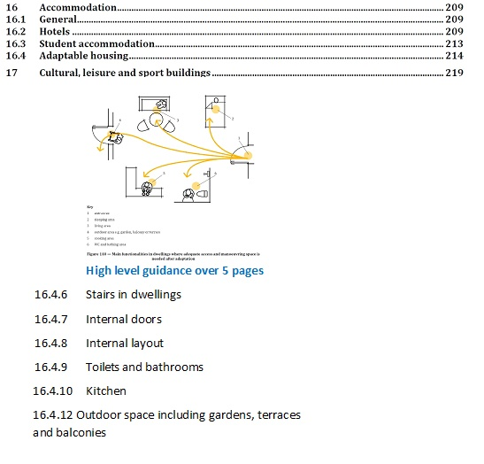

Why develop a Standard for Universal Design Dwellings?, Ruth O’Reilly

Sustainable Cities and Communities

SDG 11: Make cities and human settlements inclusive, safe, resilient and sustainable.

Census 2016

- 27.5% of households in Ireland with at least one person with a disability
- Increasing percentage of older people in our population – 15% in 2020, to reach 18% by 2030, 27% by 2050

Housing Continuum

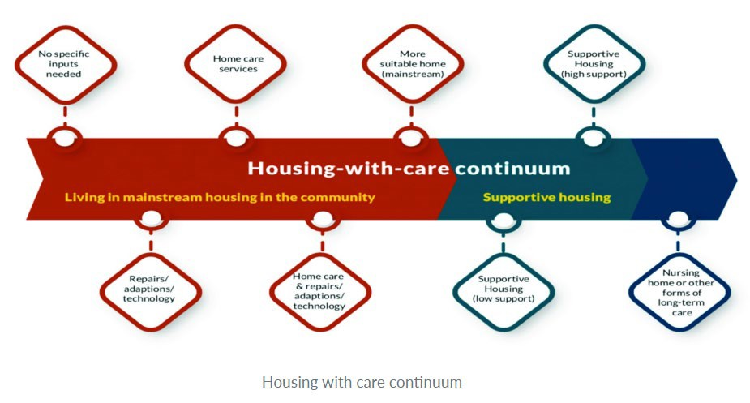

Part M, Minimum Requirements

M1 Adequate provision shall be made for people to access and use a building, its facilities and its environs.
TGD M 0.1 General
The requirements of Part M (M1 – M5) aim to ensure that regardless of age, size or disability:
- New buildings other than dwellings are accessible and usable……
- New dwellings are visitable.

Housing Options for our Ageing Population

Action 4.6: In partnership with industry, introduce measures to ensure that over a five year period delivery is increased to ensure that 30% of all new dwellings
are built to incorporate universal design principles to accommodate our ageing population.

National Housing Strategy for Disabled People

Theme 1 – Accessible Housing and Communities
Outcomes: There is an increase in the provision of accessible housing for disabled people by the setting of local, need-related targets for all social housing providers using a universal design approach, as appropriate.

Local Authority Development Plans
(source: Age Friendly Ireland)
Carlow: 5% min in excess of 20
Dublin City: 25% of apartments in excess of 10
Donegal (draft): 30% in excess of 7 (less than 7, at least 1 unit)
Fingal (draft): 10% Excess of 100 units (private) 30% social
Meath: 5% in excess of 20 units
Roscommon: Minimum 10% in excess of 10 units
Westmeath: Minimum of 5% in excess of 20 units
Wexford: 20% of residential schemes in excess of 5

Universal Design Guidelines for Homes in Ireland

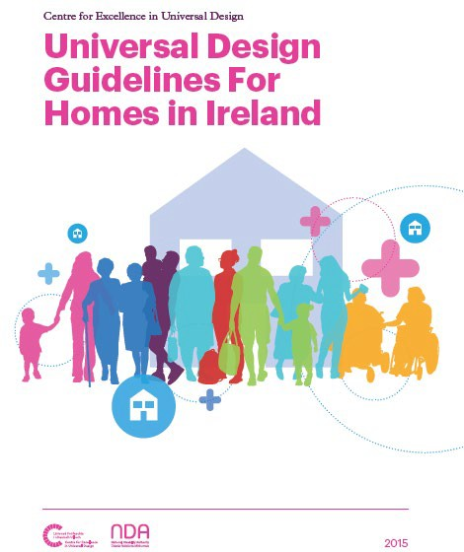

Examples of Additional Sources

Dementia Friendly Dwellings for People with Dementia, their Families and Carers, NDA
Best Practice Access Guidelines Designing Accessible Environments, IWA
Housing Design Guidelines for Occupational Therapists, AOTI
Selected European and international standards and guidelines

Title and Scope of New Standard

Title

Universal Design Dwellings – Requirements and recommendations.

Scope of new standard

The scope defines what the standard will include.
It also informs the reader of the document what is excluded from the standard.

Scope of new standard (1)

This document specifies requirements and recommendations for new dwellings through a Universal Design approach – dwellings that can be accessed, understood and used by all people to the greatest extent possible, regardless of their age, size, ability or disability.
This document specifies requirements and recommendations for the design of accessible, usable, flexible and adaptable Universal Design Dwellings, ranging from apartments to individual houses.

Scope of new standard (2)

It includes external access routes to dwellings, parking, communal areas, entrances and circulation areas within dwellings, key rooms and facilities within dwellings and private open spaces.

This document provides requirements and recommendations for two categories of Universal Design dwellings.

Scope of new standard (3)

This document can be used for assessing the design of existing dwellings and to inform retrofit and refurbishments.
This document can be used for purpose-designed dwellings or residential facilities for older or disabled people but does not include requirements for assistance, health and social care facilities that may be required in these settings.

Comfort Break Back in 10 mins

Standards Development Process and Timelines, Tom Grey

Intended users of this Standard

- Government departments and agencies
- Local Authorities
- Public and Private Procurement
- Built-Environment Design Professionals
- Builders & Developers
- Access Consultants
- And others

Stakeholders participation at National level

All stakeholders/interested parties are encouraged to participate in this work https://www.nsai.ie/standards/standards- committees/get-involved-in-standards- development/

NSAI process is that standards are developed by consensus.

Expectations & Requirements for Engagement and participation

- Through the NSAI National Committee NSAI/TC 023/SC 01/WG6 ” UD Dwellings”
- Attendance at meetings
- Participation in discussions
- Review of draft, submission of comments on the draft

Consultation Phase

- Public Consultation Phase (Public enquiry ) – open to persons outside the committee (NSAI/TC 023/SC 01/WG6 )
- Via consultation workshops
- Via the commenting phase
- NSAI open platform called ”Your Standards Your Say ( YSYS) - http://www.nsainep.ie/

Timelines for the development of the Standard
May 2023 – Kick off meeting of the NSAI/TC 023/SC 01/WG6 ”UD Dwellings”
May – September 2023 – Development of the draft content
October 2023 – Finalisation of text & preparation for sending to Public Enquiry
November 2023 – January 2024 – Public Enquiry /Consultation Period
January 2024 – End of Public consultation period
February – April 2024 – Review of comments submitted & updating of draft
May – July 2024 - Finalisation of content of standard
July - Oct 2024 – to editing, NSAI approval process
November 2024 - January 2025 – Publication

Next Steps
Register your interest on the NSAI Membership platform https://www.nsai.ie/standards/standards-committees/get-involved-in- standards-development/

KICK OFF MEETING 2nd MAY 2023
Work commences on developing the content of the proposed standard using a baseline document
BETWEEN MEETINGS
Committee members are required to review draft text, submit comments on draft text
DURING MEETINGS
Review comments submitted and agree revised text
Make notes/observations

Participation in NSAI/TC 023/SC 01/WG6 ” UD Dwellings”
If you want to join this work and the Technical Committee

You need to Register on the NSAI Standards Membership platform

Register your interest in becoming a member of the Committee at this link :
https://www.nsai.ie/standards/standards-committees/get- involved-in-standards-development/
Once registered , your application will be assessed.

Q&A Session, Fíonnadh McGonigle

Wrap Up, Ruth O’Reilly

Meeting Dates – NSAI/TC23/SC1/WG6

Kick off Meeting - Tuesday 2nd of May, 14.30 to 16.00
2nd Meeting -Tuesday 30th May 14.30 to 16.30
Meetings will be held via Zoom
Further meetings will be planned in June through September

Thank you all for participating

Questions to Elizabeth O’Ferrall, NSAI, Elizabeth.OFerrall@nsai.ie

Close of Session

