|  |  |
| --- | --- |
| **Agrément** | |
| **Form Title WINDOW ENERGY PERFORMANCE**  **(WEP) APPLICATION FORM** | **Reference F-IAB-012**  **Page Page 1 of 6**  **Revision 3** |

Please complete all sections and submit electronically to [Sustainability@nsai.ie](mailto:Sustainability@nsai.ie)

**Section 1.0 - Company Details**

|  |  |  |  |  |  |
| --- | --- | --- | --- | --- | --- |
| Company Name |  | | | | |
| Address |  | | | | |
| Telephone |  | | E-Mail |  | |
| Fax |  | | Website |  | |
| Trading Name (if different from above) | |  | | | |
| Company Contact |  | | | | |
| Job Title |  | | | | |
| Personal E-mail |  | | | | |
| 2nd Contact Name |  | | | | |
| Indicate your company’s Quality Management System (QMS); ISO 9001 or I.S. EN 14351-1:2006 Factory Production Control (FPC) or similar documented system. **Give details of the QMS** | | | | |  |

**Section 2.0 – Window Assembly Details –** complete for each window arrangement.

|  |  |  |  |  |  |  |  |  |  |  |  |  |
| --- | --- | --- | --- | --- | --- | --- | --- | --- | --- | --- | --- | --- |
| WEP Certificate Number. (Office Only) | | | | |  | | | | | | | |
| Frame Material (aluminium, PVC-U, steel, timber or a combination of materials). | | | | |  | | | | | | | |
| Window Description, Technical Summary. Gas/Glass thickness/ emissivity etc. | | | | |  | | | | | | | |
| Glazing unit (Double/Triple) | | | | |  | | | | | | | |
| Window Type | Casement – Fixed Light/Side Hung 1480 High x 1230 Wide | | | | | | | | |  | | |
| Casement – Fixed Light/Tilt & Turn 1480 High x 1230 Wide | | | | | | | | |  | | |
| Vertical Sliding Sash - 1480 High x 1230 Wide | | | | | | | | |  | | |
| Product/assembly Name | | |  | | | | | | | | | |
| Certified Simulator | | |  | | | | | | | | | |
| Address | |  | | | | | | | Telephone | |  | |
| **WEP Index** *3DP* | |  | | | | **WEP Rating** (A1,A2,A3,B etc) | | | | | |  |
| Thermal Transmittance Uwindow | | | | (W/m2.K) *2DP* | | | |  | | | | |
| Effective Air Leakage Lfactor | | | | (W/m2.K) *2DP* | | | |  | | | | |
| Solar Factor gwindow | | | | *2DP* | | | |  | | | | |
| Solar Energy Transmittance (g┴) | | | | *2DP* | | | |  | | | | |
| Thermal Transmittance Window Uwindow (W/m2.K) *2DP* | | | | | | | |  | | | | |
| Air Leakage Report – Report number and testing | | | | | | |  | | | | | |
| agency. | | | | | | | L600 = L50 = | | | | | |
| Confirm window arrangement achieves a L600 Class 4 classification to I.S. EN 12207:199911 | | | | | | |

**Applicant Name: Date:**

# Application Form –Guidance Notes.

## Guidance notes for completion of WEP Application process.

1. Prior to applying for a WEP rating, manufactures are advised to engage the services of a Certified Simulator, to carry out an initial assessment of their window assembly. This should give a good indication as to your likely WEP rating. In addition, the initial assessment, will allow you the opportunity to make amendments to the product specification to improve the final WEP rating.
2. 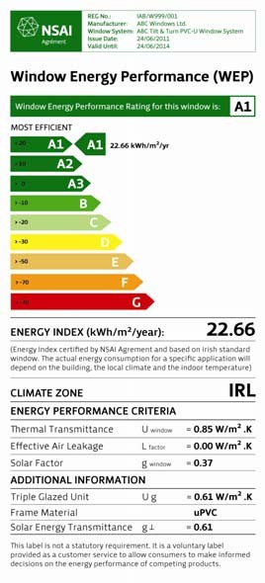Manufactures must install a recognised Quality Management system (ISO 9001 or similar documented system). Details of your management system and procedures should accompany your WEP application. If no such quality management system exists, manufactures must implement one and this system should have a minimum of 3 months operating history prior to the date of audit.
3. Once satisfied with your Certified Simulator’s rating, you should submit all documentation to NSAI Agrément. This should include completed application form, test reports, along with your full assessors report, your quality management documentation and application fees.
4. The NSAI Agrément fee structure is associated with each label that you register and is charged on an annual basis. See [**www.nsai.ie**](http://www.nsai.ie/)for the current fee structure. The Certified Simulator fees are separate and should be paid directly to them. If independent testing is required then these costs are separate and should be paid directly to the independent testing agency.
5. Upon receipt of the appropriate fee, the NSAI will carry out an audit of your manufacturing facility and assess your Certified Simulator’s report.

Sample WEP Certificate

1. Once successful completion of stage 5, your company will be registered with the NSAI and each successful window assembly will be issued with a unique registration number. The registration number must be displayed on the reveal of the fixed sash jamb or fixed sash head (F10 or F8 or F6 see Fig. 1.0). Each window type will be issued with a WEP Certificate number and permits the manufacturer to affix the Energy rating identification mark to their product.
2. The WEP rating is calculated by combining the **Thermal transmittance (Uw), Solar factor (g-value)** and **Window air leakage (L50)** factors using the following formula



**WEP Rating = 218.6 x g-value - 68.5 (Uw +L50)**

## Guidance notes for Certified Simulator’s assessment.

1. **Analysis Method**

Simulators must state the analysis method’s used. This including all software packages used and copies of all independent test report from which data has been incorporated into the Simulator’s report.

## Validation of Program

The analysis software used in assessing the thermal performance of any window assembly must be validated against the proofs in Annex D (D1 to D10) of IS EN ISO 10077-2:20032 *Thermal Perform of Windows, Doors and Shutters - Calculation of Thermal Transmittance- Part 2: numerical Method for Frames*. A statement to this effect must be contained within the Simulator’s report.

## Standard Window assembly.

The standard window assembly used to calculate the WEP ratings shall be a single opening casement type 1480 high x 1230 wide as shown in figure 1.0. Window assemblies must comply with the requirements of TGD to Part D of the building regulations. All window assemblies must be I.S. EN 127914-19 compliant.

## Thermal transmittance Window Uwindow (Uw).

The thermal transmittance of the standardised window assembly shall be calculated by combining the thermal transmittance of the glazing (Ug) with the thermal transmittance of the frame (Uf) and the linear thermal transmittance due to the combined thermal effects of the glazing, spacer and frame (Ψg).

**Frame thermal transmittance (Uf)** shall be determined by using:

I.S. EN ISO 10077-1:20061 *Thermal Perform of Win Doors and Shutters Cal of Thermal Transmittance Part 1: General*, Table F.1

or by calculation using:

I.S. EN ISO 10077-1:20061 or

I.S. EN ISO 10077-1:20061 and I.S. EN ISO 10077-22 *Thermal Perform of Win Doors and Shutters Cal of Thermal Transmittance Part 2: Numerical Method for Frames*

or by hot box method using:

I.S.EN12412-2-20034 *Thermal Performance of windows, Doors and Shutters - Determination of Thermal Transmittance by Hot Box Method - Part 2: Frames* as *appropriate.*

The **thermal transmittance of the glazing (Ug)** shall be determined by calculations using I.S EN 6736 Glass in building - *Determination of thermal Transmittance (U-Value) - Calculation Method*; or measured according to I.S.EN674-19987 *Glass in building - Determination of Thermal Transmittance - Hot Plate Method* or I.S.EN675-19988 *Glass in Building - Determination of Thermal Transmittance - Heat Flow Meter Method*;

**Linear thermal transmittance (ψg)** due to the combined thermal effects of the glazing, spacer and frame must be assessed following the principles of I.S. EN ISO10077-22

## or

Determination of complete **thermal transmittance (Uw)** by the hot-box method in accordance with I.S. EN ISO 12567-1:20015 *Thermal Performance of windows DOORS - Determination of Thermal Transmittance by Hot Box Method -Part 1: Complete Windows and Doors*

## Effective Air Leakage (L50 or Lfactor)

Determine the Effective Air Leakage per unit length of opening length at both 600Pa and 50Pa in accordance with:

BS 6375-1:20099 *Performance of windows and doors – Part 1: Classification for weather tightness and guidance on selection and specification*

or

I.S. EN 12207:199911 *Windows and doors - Air permeability - Classification*

and

I.S. EN 102610*, Windows and doors — Air permeability — Test method.*

It shall not be necessary to carry out the sequence of tests as outlined in Clause 5 of BS 6375-1:20099 namely parts b, c, d and e. The specimen shall be tested in accordance with Clause 6 of BS 6375-1:20099 and/or I.S. EN 102610 and the test shall be conducted with both positive and negative pressures. The test pressure shall be applied in steps of 50 Pa up to 300 Pa and from 300 Pa in steps of 150 Pa up to 600 Pa maximum. The test result, defined as the numerical average of the positive and negative air permeability values (m3/h) at each pressure step, shall be expressed and classified in accordance with I.S. EN 12207:199911. While the L50 value is used in calculating the WEP rating all window assemblies must achieve a L600 Class 4 classification to I.S. EN 12207:199911.

Calculate the total air leakage as a fraction of the total area and convert the L50 factor to Heat Energy loss by multiplying by the conversion factor 0.0165 Wh/Km3.

## Total solar energy transmittance (g-value).

Determine the solar energy transmittance (g┴) in accordance with I.S. EN 41012, *Glass in building — Determination of luminous and solar characteristics of glazing.* The solar energy transmittance g┴ should be converted to the time-averaged transmittance as per I.S. EN 832:199813 T*hermal Performance of Buildings - calculation of Energy use for Heating - Residential Buildings*.

When using Manufacturers’ values you must provide reports from the manufacture confirmation the values used I.S. EN 41012

## Summary of Results

Reports must contain a summary of results. All information required to verify the analysis must be submitted in electronic format (i.e. CD).

Simulation reports must list out all materials used and their thermal conductivity used. Reports must list the frame thermal transmittance (Uf) for the fixed frame, the sash and the Mullion in W/(m2.K). Reports must list the Liniar thermal transmittance (ψ) for the fixed frame, the sash and the Mullion in W/(m.K).

AutoCAD drawings of the overall window assembly at a scale not greater that 1:10 with sectional details of all frame and glazing section (scale 1:2) must be provided. The drawings must label all component parts and their thermal conductance used.

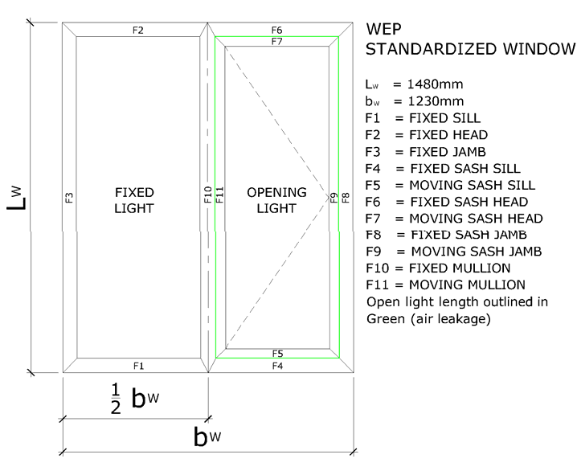

Figure 1.0

## Normative references

Classification standards, Test and calculation standards.

1. **I.S. EN ISO 10077-1:2006** *Thermal Perform of Win Doors and Shutters Cal of Thermal Transmittance Part 1: General*
2. **I.S. EN ISO 10077-2:2003** *Thermal Perform of Win Doors and Shutters Cal of Thermal Transmittance Part 2: Numerical Method for Frames*
3. **I.S. EN 14351-1:2006** *Windows and Doors - Product Standard, Performance Characteristics - Part 1: Windows and External Pedestrian Doorsets without Resistance to fire and/or smoke Leakage Characteristics*.
4. **I.S. EN 12412-2:2003** *Thermal Performance of windows, Doors and Shutters - Determination of Thermal Transmittance by Hot Box Method - Part 2: Frames*
5. **I.S. EN ISO 12567-1:2001** *Thermal Performance of windows DOORS - Determination of Thermal Transmittance by Hot Box Method -Part 1: Complete Windows and Doors*
6. **I.S EN 673:1998** *Glass in building* - *Determination of thermal Transmittance (U- Value) - Calculation Method*
7. **I.S. EN 674:1998** *Glass in building - Determination of Thermal Transmittance - Hot Plate Method*
8. **I.S. EN 675:1998** *Glass in Building - Determination of Thermal Transmittance - Heat Flow Meter Method*
9. **BS 6375-1:2009** *Performance of windows and doors – Part 1: Classification for weather tightness and guidance on selection and specification*
10. **I.S. EN 1026:2000** *Windows and doors — Air permeability — Test method.*
11. **I.S. EN 12207:1999** *Windows and doors - Air permeability - Classification*
12. **I.S. EN 410** *Glass in building — Determination of luminous and solar characteristics of glazing*
13. **I.S. EN 832:1998** *Thermal Performance of Buildings - calculation of Energy use for Heating - Residential Buildings*
14. **I.S. EN 1279-1:2004** *Glass in Building - Insulating glass units - Part 1: Generalities, Dimensional Tolerances and Rules for the system description*
15. **I.S. EN 1279-2:2002** *Glass in building - Insulating glass units - Part 2: Long term test method and requirements for moisture penetration.*
16. **I.S. EN 1279-3:2002** *Glass in building - Insulating glass units - Part 3: Long term test method and requirements for gas leakage rate and for gas concentration tolerances*
17. **I.S. EN 1279-4:2002** *Glass in building - Insulating glass units - Part 4: Method of test for the physical attributes of edge seal*
18. **I.S. EN 1279-5:2005** *Glass in building - Insulating glass units - Part 5: Evaluation of conformity*
19. **I.S. EN 1279-6:2002** *Glass in building - Insulating glass units - Part 6: Factory production control and periodic tests*
20. **I.S. EN 10088-1:2005** *Stainless steels - Part 1: List of stainless steels*
21. **I.S. EN 514:2000** *Unplasticized polyvinylchloride (PVC-U) profiles for the fabrication of windows and doors - Determination of the strength of welded corners and T-joints*
22. **I.S. EN 14220:2006** *Timber and wood-based materials in external windows, external door leaves and external door frames - Requirements and specifications*
23. **BS 644:2009** *Timber windows – Fully finished factory-assembled windows of various types – Specification*
24. **I.S. EN 12608:2003** *Unplasticized polyvinylchloride (PVC-U) profiles for the fabrication of windows and doors - Classification, requirements and test methods.*
25. **BS 7412:2007** *Specification for windows and doorsets made from unplasticized polyvinyl chloride (PVC-U) extruded hollow profiles*