Please complete all sections and submit NSAI
Section 1.0 - Company Details
Company Name
Address
Telephone |  |  | E-Mail
Fax |  |  | Website
Trading Name (if different from above)
Company Contact
Job Title
Personal E-mail
2nd Contact Name
Indicate your company’s Quality Management System (QMS); ISO 9001 or I.S. EN 14351-1:2006 Factory Production Control (FPC) or similar documented system. Give details of the QMS
Section 2.0 – Window Assembly Details – complete for each window arrangement.
WEP Certificate Number. (Office Only)
Frame Material (aluminium, PVC-U, steel, timber or a combination of materials).
Window Description, Technical Summary. Gas/Glass thickness/ emissivity etc.
Glazing unit (Double/Triple)
Window Type | Casement – Fixed Light/Side Hung 1480 High x 1230 Wide
Window Type | Casement – Fixed Light/Tilt & Turn 1480 High x 1230 Wide
Window Type | Vertical Sliding Sash - 1480 High x 1230 Wide
Product/assembly Name
Certified Simulator
Address |  |  |  |  |  |  |  | Telephone
WEP Index 3DP |  |  |  |  | WEP Rating (A1,A2,A3,B etc)
Thermal Transmittance U_{window} (W/m².K) 2DP
Effective Air Leakage L_{factor} (W/m².K) 2DP
Solar Factor g_{window} 2DP
Solar Energy Transmittance (g┴) 2DP
Thermal Transmittance Window U_{window} (W/m².K) 2DP
Air Leakage Report – Report number and testing agency.
Confirm window arrangement achieves a L₆₀₀ Class 4 classification to I.S. EN 12207:1999¹¹ |  |  |  |  |  | L₆₀₀ =
 |  |  |  |  |  | L₅₀ =

Applicant Name: _________________________ Date: ______________

Guidance notes for completion of WEP Application process.
- Prior to applying for a WEP rating, manufactures are advised to engage the services of a Certified Simulator, to carry out an initial assessment of their window assembly. This should give a good indication as to your likely WEP rating. In addition, the initial assessment, will allow you the opportunity to make amendments to the product specification to improve the final WEP rating.
- Manufactures must install a recognised Quality Management system (ISO 9001 or similar documented system). Details of your management system and procedures should accompany your WEP application. If no such quality management system exists, manufactures must implement one and this system should have a minimum of 3 months operating history prior to the date of audit.
Sample WEP Certificate
- Once satisfied with your Certified Simulator’s rating, you should submit all documentation to NSAI Agrément. This should include completed application form, test reports, along with your full assessors report, your quality management documentation and application fees.
- The NSAI Agrément fee structure is associated with each label that you register and is charged on an annual basis. See www.nsai.ie for the current fee structure. The Certified Simulator fees are separate and should be paid directly to them. If independent testing is required then these costs are separate and should be paid directly to the independent testing agency.
- Upon receipt of the appropriate fee, the NSAI will carry out an audit of your manufacturing facility and assess your Certified Simulator’s report.
- Once successful completion of stage 5, your company will be registered with the NSAI and each successful window assembly will be issued with a unique registration number. The registration number must be displayed on the reveal of the fixed sash jamb or fixed sash head (F10 or F8 or F6 see Fig. 1.0). Each window type will be issued with a WEP Certificate number and permits the manufacturer to affix the Energy rating identification mark to their product.
- The WEP rating is calculated by combining the Thermal transmittance (U_{w}), Solar factor (g-value) and Window air leakage (L₅₀) factors using the following formula

WEP Rating = 218.6 x g-value - 68.5 (U_{w} +L₅₀)

Guidance notes for Certified Simulator’s assessment.
- Analysis Method
Simulators must state the analysis method’s used. This including all software packages used and copies of all independent test report from which data has been incorporated into the Simulator’s report.

- Validation of Program
The analysis software used in assessing the thermal performance of any window assembly must be validated against the proofs in Annex D (D1 to D10) of IS EN ISO 10077-2:2003² Thermal Perform of Windows, Doors and Shutters - Calculation of Thermal Transmittance- Part 2: numerical Method for Frames. A statement to this effect must be contained within the Simulator’s report.

Standard Window assembly.
The standard window assembly used to calculate the WEP ratings shall be a single opening casement type 1480 high x 1230 wide as shown in figure 1.0. Window assemblies must comply with the requirements of TGD to Part D of the building regulations. All window assemblies must be I.S. EN 1279¹⁴⁻¹⁹ compliant.

Thermal transmittance Window U_{window} (U_{w}).
The thermal transmittance of the standardised window assembly shall be calculated by combining the thermal transmittance of the glazing (U_{g}) with the thermal transmittance of the frame (U_{f}) and the linear thermal transmittance due to the combined thermal effects of the glazing, spacer and frame (ψ_{g}).

Frame thermal transmittance (U_{f}) shall be determined by using:
I.S. EN ISO 10077-1:2006¹ Thermal Perform of Win Doors and Shutters Cal of Thermal Transmittance Part 1: General, Table F.1
or by calculation using:
I.S. EN ISO 10077-1:2006¹ or
I.S. EN ISO 10077-1:2006¹ and I.S. EN ISO 10077-2² Thermal Perform of Win Doors and Shutters Cal of Thermal Transmittance Part 2: Numerical Method for Frames
or by hot box method using:
I.S.EN12412-2-2003⁴ Thermal Performance of windows, Doors and Shutters - Determination of Thermal Transmittance by Hot Box Method - Part 2: Frames as appropriate.

The thermal transmittance of the glazing (U_{g}) shall be determined by calculations using I.S EN 673⁶ Glass in building - Determination of thermal Transmittance (U-Value) - Calculation Method; or measured according to I.S.EN674-1998⁷ Glass in building - Determination of Thermal Transmittance - Hot Plate Method or I.S.EN675-1998⁸ Glass in Building - Determination of Thermal Transmittance - Heat Flow Meter Method;

Linear thermal transmittance (ψ_{g}) due to the combined thermal effects of the glazing, spacer and frame must be assessed following the principles of I.S. EN ISO10077-2²

or

Determination of complete thermal transmittance (U_{w}) by the hot-box method in accordance with I.S. EN ISO 12567-1:2001⁵ Thermal Performance of windows DOORS - Determination of Thermal Transmittance by Hot Box Method -Part 1: Complete Windows and Doors

Effective Air Leakage (L₅₀ or L_{factor})

Determine the Effective Air Leakage per unit length of opening length at both 600Pa and 50Pa in accordance with:

BS 6375-1:2009⁹ Performance of windows and doors – Part 1: Classification for weather tightness and guidance on selection and specification

or

I.S. EN 12207:1999¹¹ Windows and doors - Air permeability - Classification
and

I.S. EN 1026¹⁰, Windows and doors — Air permeability — Test method.

It shall not be necessary to carry out the sequence of tests as outlined in Clause 5 of BS 6375-1:2009⁹ namely parts b, c, d and e. The specimen shall be tested in accordance with Clause 6 of BS 6375-1:2009⁹ and/or I.S. EN 1026¹⁰ and the test shall be conducted with both positive and negative pressures. The test pressure shall be applied in steps of 50 Pa up to 300 Pa and from 300 Pa in steps of 150 Pa up to 600 Pa maximum. The test result, defined as the numerical average of the positive and negative air permeability values (m³/h) at each pressure step, shall be expressed and classified in accordance with I.S. EN 12207:1999¹¹. While the L₅₀ value is used in calculating the WEP rating all window assemblies must achieve a L₆₀₀ Class 4 classification to I.S. EN 12207:1999¹¹.

Calculate the total air leakage as a fraction of the total area and convert the L₅₀ factor to Heat Energy loss by multiplying by the conversion factor 0.0165 Wh/Km³.

Total solar energy transmittance (g-value).

Determine the solar energy transmittance (g┴) in accordance with I.S. EN 410¹², Glass in building — Determination of luminous and solar characteristics of glazing. The solar energy transmittance g┴ should be converted to the time-averaged transmittance as per I.S. EN 832:1998¹³ Thermal Performance of Buildings - calculation of Energy use for Heating - Residential Buildings.

When using Manufacturers’ values you must provide reports from the manufacture confirmation the values used I.S. EN 410¹²

Summary of Results
Reports must contain a summary of results. All information required to verify the analysis must be submitted in electronic format (i.e. CD).

Simulation reports must list out all materials used and their thermal conductivity used. Reports must list the frame thermal transmittance (U_{f}) for the fixed frame, the sash and the Mullion in W/(m².K). Reports must list the Liniar thermal transmittance (ψ) for the fixed frame, the sash and the Mullion in W/(m.K).

AutoCAD drawings of the overall window assembly at a scale not greater that 1:10 with sectional details of all frame and glazing section (scale 1:2) must be provided. The drawings must label all component parts and their thermal conductance used.

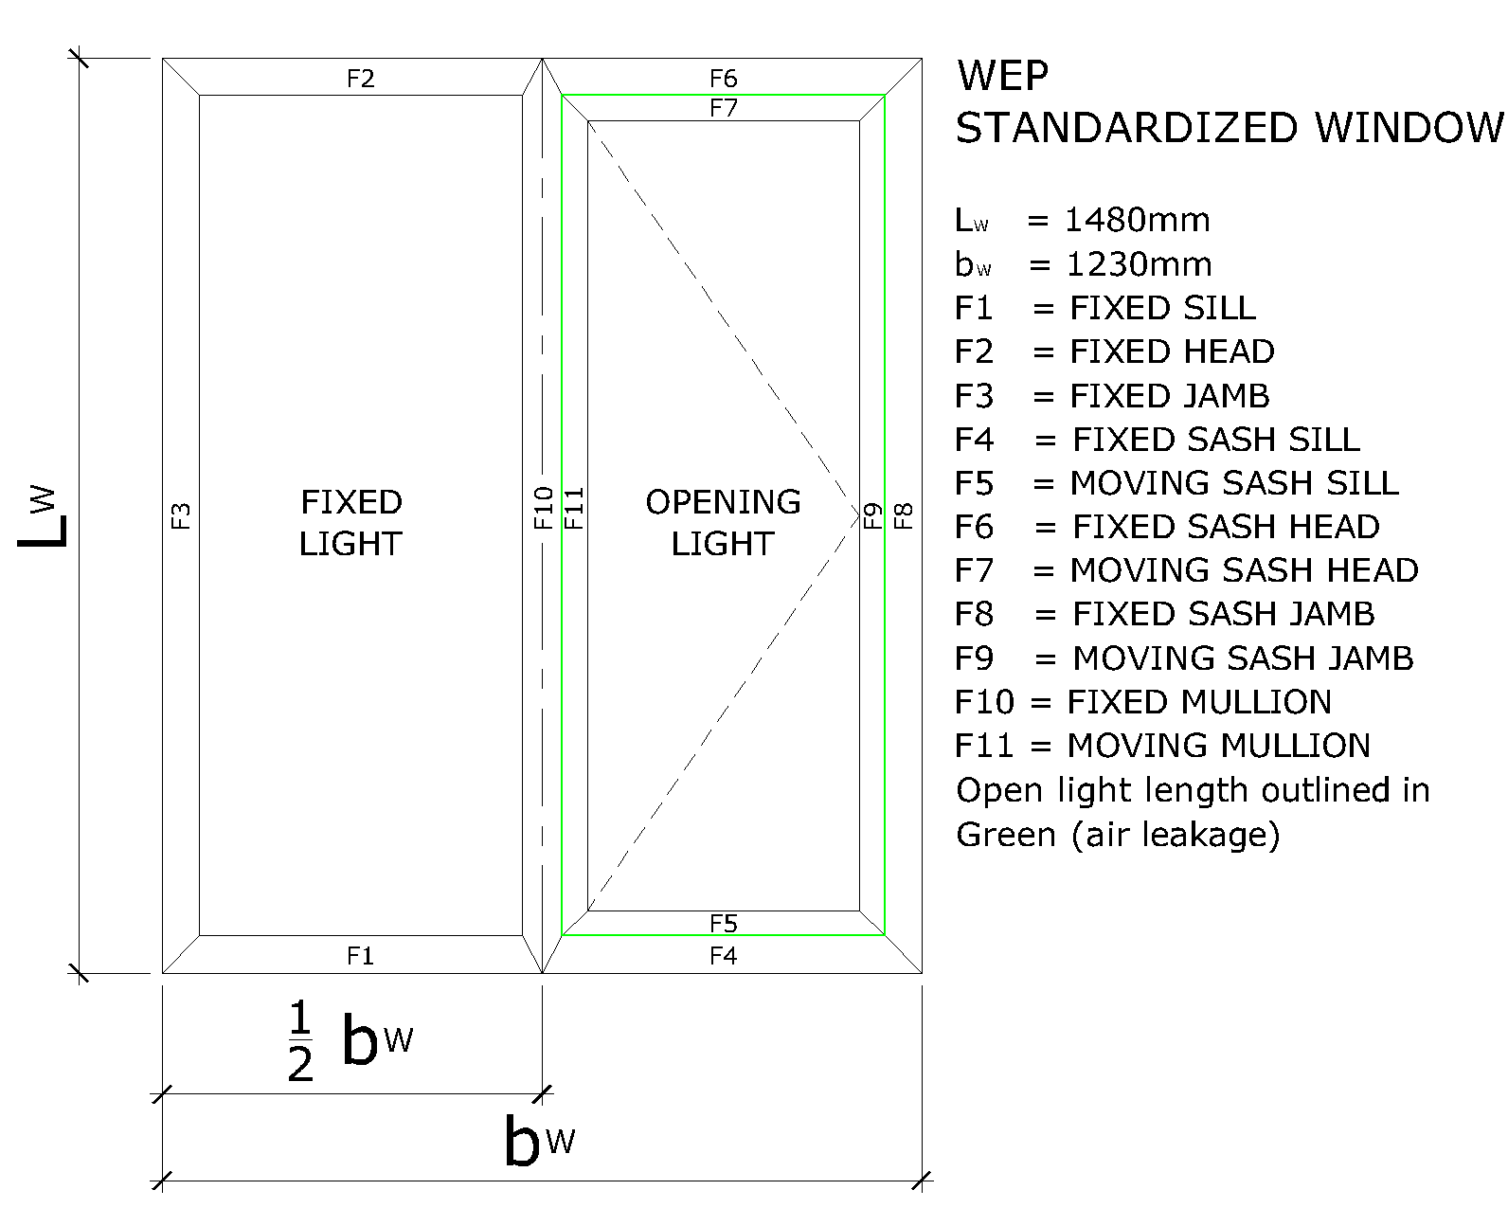
Figure 1.0
Normative references
Classification standards, Test and calculation standards.

- I.S. EN ISO 10077-1:2006 Thermal Perform of Win Doors and Shutters Cal of Thermal Transmittance Part 1: General
- I.S. EN ISO 10077-2:2003 Thermal Perform of Win Doors and Shutters Cal of Thermal Transmittance Part 2: Numerical Method for Frames
- I.S. EN 14351-1:2006 Windows and Doors - Product Standard, Performance Characteristics - Part 1: Windows and External Pedestrian Doorsets without Resistance to fire and/or smoke Leakage Characteristics.
- I.S. EN 12412-2:2003 Thermal Performance of windows, Doors and Shutters - Determination of Thermal Transmittance by Hot Box Method - Part 2: Frames
- I.S. EN ISO 12567-1:2001 Thermal Performance of windows DOORS - Determination of Thermal Transmittance by Hot Box Method -Part 1: Complete Windows and Doors
- I.S EN 673:1998 Glass in building - Determination of thermal Transmittance (U-Value) - Calculation Method
- I.S. EN 674:1998 Glass in building - Determination of Thermal Transmittance - Hot Plate Method
- I.S. EN 675:1998 Glass in Building - Determination of Thermal Transmittance - Heat Flow Meter Method
- BS 6375-1:2009 Performance of windows and doors – Part 1: Classification for weather tightness and guidance on selection and specification
- I.S. EN 1026:2000 Windows and doors — Air permeability — Test method.
- I.S. EN 12207:1999 Windows and doors - Air permeability - Classification
- I.S. EN 410 Glass in building — Determination of luminous and solar characteristics of glazing
- I.S. EN 832:1998 Thermal Performance of Buildings - calculation of Energy use for Heating - Residential Buildings
- I.S. EN 1279-1:2004 Glass in Building - Insulating glass units - Part 1: Generalities, Dimensional Tolerances and Rules for the system description
- I.S. EN 1279-2:2002 Glass in building - Insulating glass units - Part 2: Long term test method and requirements for moisture penetration.
- I.S. EN 1279-3:2002 Glass in building - Insulating glass units - Part 3: Long term test method and requirements for gas leakage rate and for gas concentration tolerances
- I.S. EN 1279-4:2002 Glass in building - Insulating glass units - Part 4: Method of test for the physical attributes of edge seal
- I.S. EN 1279-5:2005 Glass in building - Insulating glass units - Part 5: Evaluation of conformity
- I.S. EN 1279-6:2002 Glass in building - Insulating glass units - Part 6: Factory production control and periodic tests
- I.S. EN 10088-1:2005 Stainless steels - Part 1: List of stainless steels
- I.S. EN 514:2000 Unplasticized polyvinylchloride (PVC-U) profiles for the fabrication of windows and doors - Determination of the strength of welded corners and T-joints
- I.S. EN 14220:2006 Timber and wood-based materials in external windows, external door leaves and external door frames - Requirements and specifications
- BS 644:2009 Timber windows – Fully finished factory-assembled windows of various types – Specification
- I.S. EN 12608:2003 Unplasticized polyvinylchloride (PVC-U) profiles for the fabrication of windows and doors - Classification, requirements and test methods.
- BS 7412:2007 Specification for windows and doorsets made from unplasticized polyvinyl chloride (PVC-U) extruded hollow profiles

